Clear Lake Scullers

High School Rowing Camp

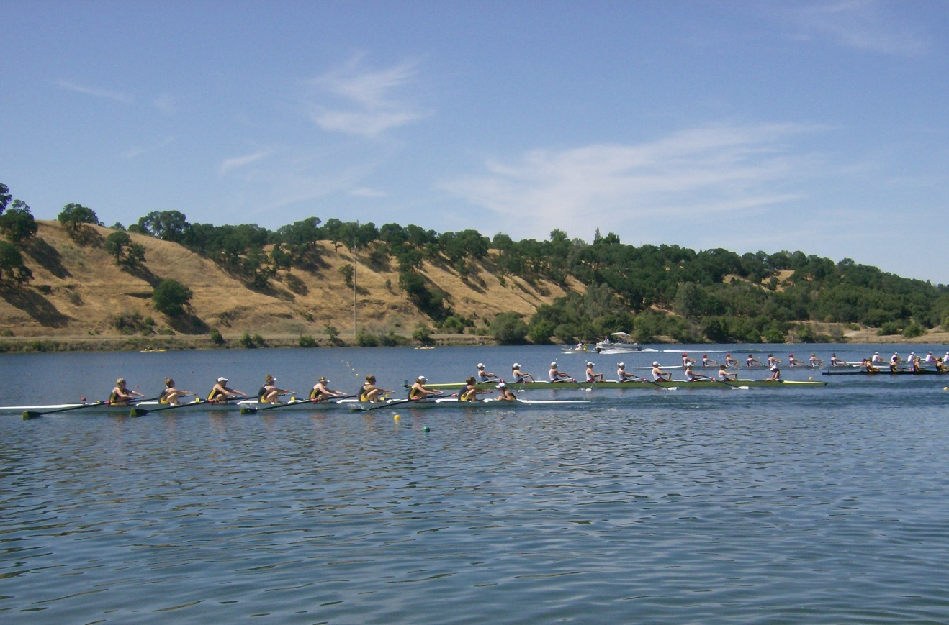

When: July 2 thru July 6, 2018 8:00 am to 10:00 am
Cost: $40

Where: Clear Lake Scullers boat yard,
Natural High School
Main Street LAKEPORT

Clear Lake Scullers is offering a rowing camp for all High School students for a week to introduce athletes to the sport. Rowing will be done in eight man shells and some sculling.
CLS offers classes and camps for adults and students for rowing, paddling, and water safety in the summer.

Contact: Mike Sullivan sul@slac.stanford.edu 707-349-9779

